

naan mudhalvan

A Project on Tracing the Growth of the Global Community:A Population Forecasting Analysis



Members

MENAKA.G- gmenaka253@gmail.com

POSULHITHAYA.S- posulhithaya@gmail.com

SHADHIKA THASKEENA.A- shadhikathaskeena@gmail.com

THANUSIYA GURUSAMY (TEAM HEAD)[- thanuvguru@gmail.com](mailto:-%20thanuvguru@gmail.com)

aiman college of arts and science for women ,Trichy

**Tracing the Growth of the Global Community: A Population Forecasting Analysis**

PROJECT REPORT TEMPLATE

1. **INTRODUCTION**
   1. Overview

Tracing the Growth of the Global Community: A Population Forecasting Analysis tells us about the growth of the Global community .Population Forecasting involves discovery of the factors that influence present and past population increase and decrease. On the basis of assumptions concerning the future of these factors, and of other factors that are just emerging in the community, projections of fertility, mortality and migration trends are made.

* 1. Purpose
* This project helps the user to understand about the population density around the world .
* Users can understand about the global density and work according to it.
* They also understand about the population analysis around the world.
* After working with this project user gets to know about the various applications used such as Mural and Tableau.
* Users also understand to work under different circumstances.
* This project enables the readers to understand the use of Empathy map and Brainstorming and Ideation map.
* A clear analysis would be given to the reader to understand about this project.

1. **PROBLEM DEFINITION AND DESIGN THINKING**

2.1 Empathy Map

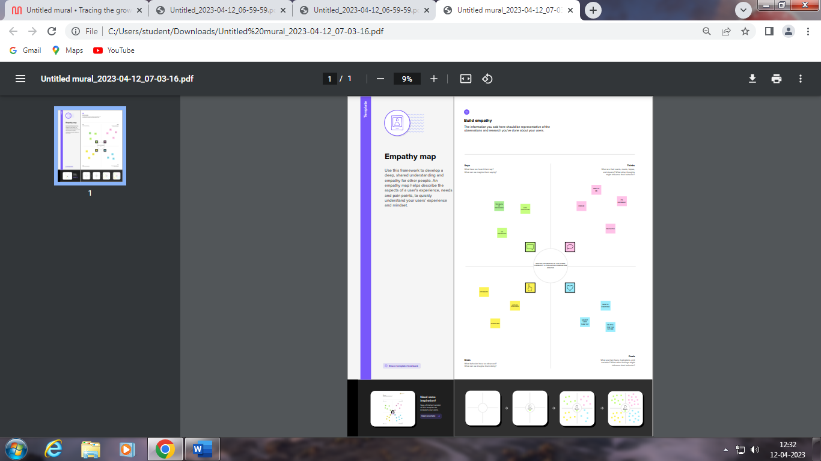

2.2 Ideation and brainstorming Map

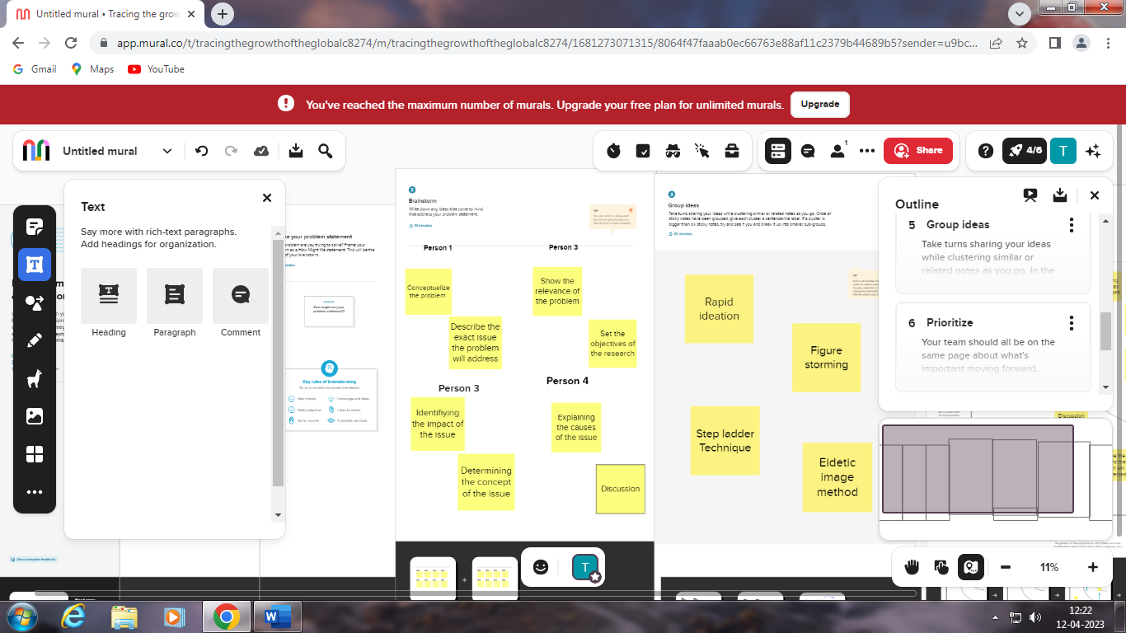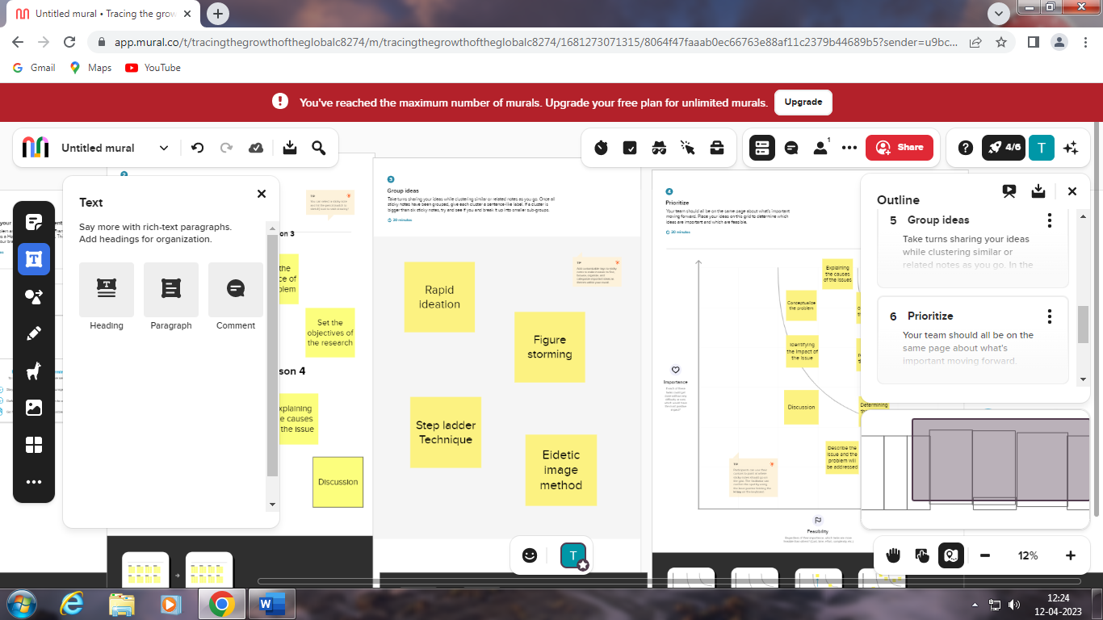

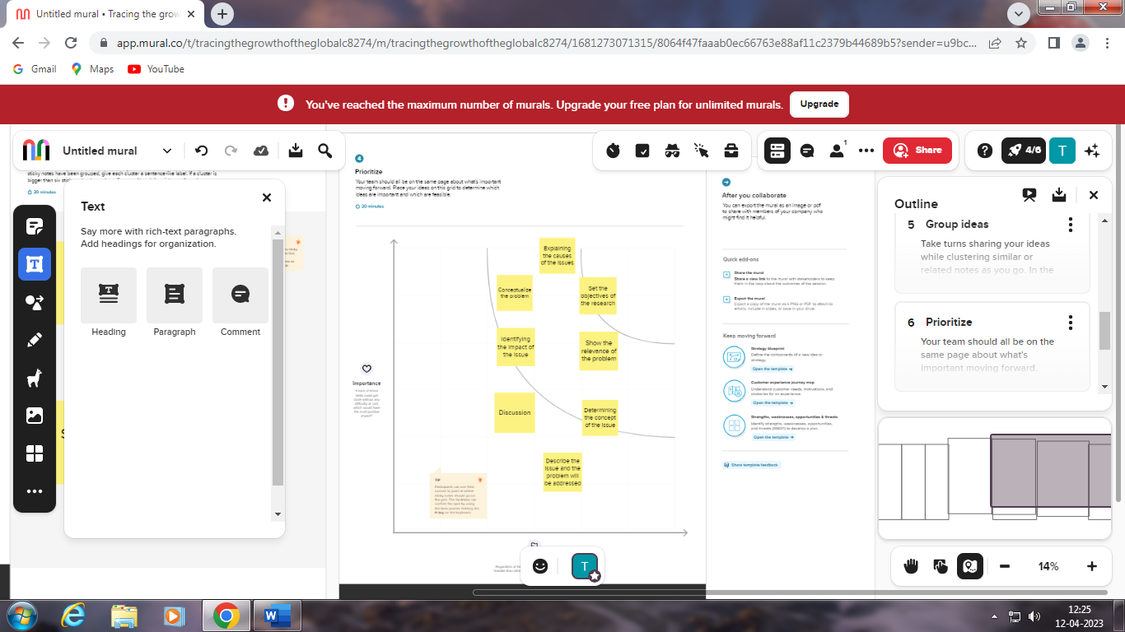

1. **RESULT**

The empathy map was prepared using the Mural Application

Similarly the brainstorming and ideation map was also created using Mural





1. **ADVANTAGES AND DISADVANTAGES**

ADVANTAGES

* Provides a quick and easy class activity. Brainstorming sessions can be effectively used in the classroom
* Contributes to classroom collective power
* Creates a student-centered activity
* Supports learning in a relaxed environment
* Strengthens problem-based learning
* Encourages creative thought.

DISADVANTAGES

* Anyone who has tried to put together a team or manage the work of many personalities to address an issue should be familiar with the drawbacks of brainstorming.
* Making decisions gets increasingly difficult. Arguments will undoubtedly come up.

**5 APPLICATIONS**

The application used for this project was Mural

Mural is a digital environment that leverages visual collaboration to help every member of your team unlock ideas and solve problems together. Visual collaboration can level the playing field for distributed teams by ensuring that everyone's voice is heard.

**6 CONCLUSION**

This online platform helped us to understand the brainstorming and ideation ideas

It helped us to recognize and work with the empathy map in Mural

We were able to understand and work with the applications.

**7 FUTURE SCOPE**

* An empathy map is a collaborative tool .
* Teams can use the to gain a deeper insight into their customers.
* Empathy maps can be used whenever you find a need to immerse yourself in an environment.
* Similarly mind mapping is also used to get all of the ideas in your head down onto paper and visual representation of the ideas.

**8 APPENDIX**

TABLE OF CONTENTS

APPENDIX A

* 1. Introduction
  2. Problem Definition and Design Thinking

1. Result
2. Advantages and Disadvantages
3. Applications
4. Conclusion
5. Future scope